Explore Wild Mexico with Quest Specialty Travel

**Adventure Mexico**

Quest Specialty Travel ● 1-833-555-TOUR (8687) ● www.questspecialtytravel.com

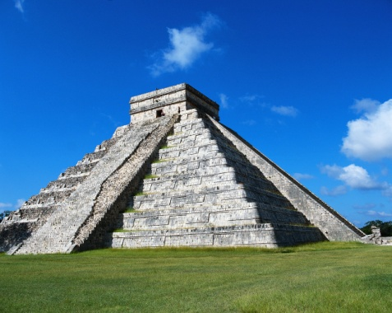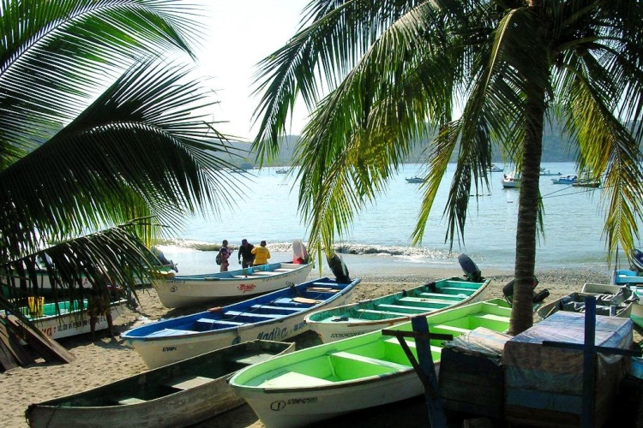Thousands of miles of Atlantic, Pacific, and Caribbean coastline, snow-capped volcanoes, stunning mountain ranges, vast deserts, immense canyons, dense jungles, and tropical forests teeming with colorful wildlife make Mexico an adventurer’s paradise. Add to that fascinating pre-Columbian ruins, exquisite secluded beaches, world-renowned cuisine, markets laden with tropical produce and native crafts, a deep-rooted music tradition, and some of the warmest, friendliest people in the world, and Mexico, without a doubt, has something for everyone. Join Quest Specialty Travel in one of our unique wilderness and cultural tours throughout Mexico. Whether exploring ancient Mayan ruins, kayaking Baja's Sea of Cortez, photographing Oaxaca's colorful markets, hiking the Copper Canyon, or relaxing in a wilderness lodge or elegant hacienda, our guided Mexico tours are full of wonder and inspiration.

**Quest Specialty Travel Mexico Destinations**

**Barranca del Cobre (Copper Canyon)**: Hike the awe-inspiring canyon of the Rio Urique, part of the largest canyon system in the world, staying in picturesque colonial towns and an indigenous Tarahumara village.

**Baja California**: Kayak the crystal clear waters of the Sea of Cortez, snorkel with sea lions, learn to surf, or experience the magic of San Ignacio’s grey whales, while enjoying rustic but luxurious wilderness accommodation.

**Oaxaca**: Journey by horse and foot from the vibrant and lively Oaxaca Valley and Sierra Madre del Sur down to the lush, tropical Oaxacan coast, staying in small artisan villages and an eco-lodge.

**Yucatan Peninsula**: Explore ancient Mayan ruins, mysterious underground caverns and rivers, and the dazzling Caribbean coast, while luxuriating in some of the finest lodges and haciendas in Mexico.

Each destination features spectacular wilderness, natural wonders, artisan villages, colorful markets, outstanding cuisine, centuries old traditions, and eco-friendly accommodation.

**Featured Quest Specialty Travel Mexico Tours**

**Oaxaca: Sierra Norte to the Pacific**

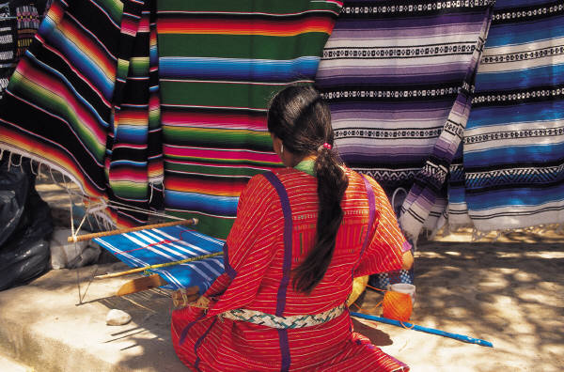

**January 15-27, February 10-22, March 11-23, April 4-16, May 1-13**

**$2949**

This exciting 12-day journey combines discovering the indigenous markets and colonial architecture of Oaxaca, with active adventure: hiking through remote mountain villages in the Sierra Norte, exploring some of the renowned archeological sights of the Zapotec and Mixtec cultures, and basking in the luscious warmth of Mexico's Southwestern tropical coast. We begin our journey in colorful and vivacious Oaxaca, where we explore markets, galleries, cafés, and the narrow streets of this colonial city. We then depart for several days of hiking in the untouched Sierra Norte, where the local Zapotec communities have set up a remote system of trails and cabins as part of a sustainable development initiative. The trip ends at a stunning eco-lodge on the Pacific coast. Here we relax and enjoy an array of activities, including kayaking, snorkeling, surfing, deep-sea fishing, scuba diving, and sailing.

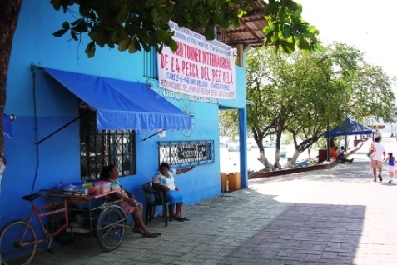

**Yucatan Peninsula: Mayan Adventure**

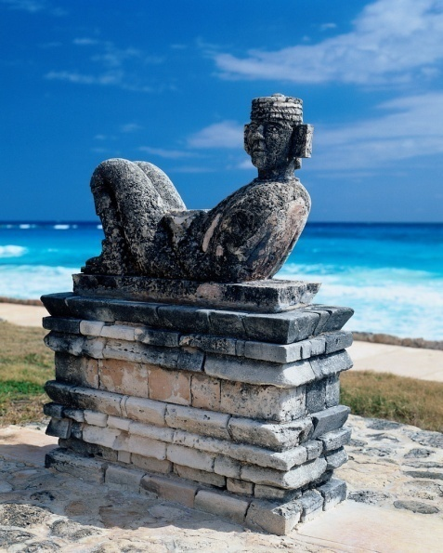

**Year-round departures**

**$1879**

This 8-day hiking, kayaking, and beach tour combines history, culture, and adventure. We explore the vibrant mangroves and forests of the Yucatan Peninsula by kayak and on foot, and visit colonial towns, local villages, and ancient Mayan ruins nestled in lush jungles. We stay in an elegant hacienda and in rustic but luxurious beachside cabanas. There is ample time to swim, snorkel, kayak, and stroll the powdery white sand beaches of the Caribbean.

**When is the best time to visit Mexico?**

Mexico’s distinct regions each have their own seasonal weather, depending on altitude and proximity to the coast. Generally, rain falls and temperatures rise from June through October, making November through May the more temperate, drier season.